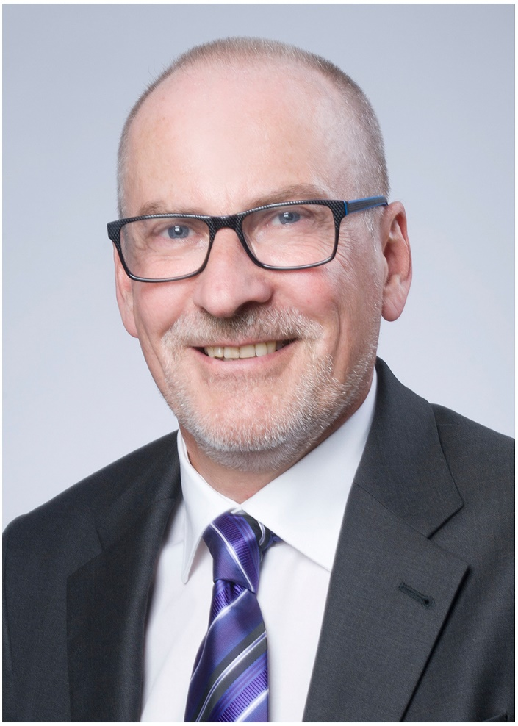

Michael Schmidt

Robert-Schumann-Straße 18

D – 65428 Rüsselsheim

Mobil: +49-(0)1624319027

E-Mail: MS@HR-Converto.com

**Profile**

result oriented connected with analytical and strategic competence,

thinking entrepreneurially,

change competence,

long-standing leadership experience in strategic and operative tasks (national and international)

* Restructuring and reorganisation experience
* Merger & Acquisition
* Change of wage systems, negotiation of wage agreements
* Restructuring of HR-Departments
* Design and implementation of processes and policies

**Experience** since 10/2010 Consultant, Interim Manager HR

Projects:

Kloeckner Metals Germany GmbH, 1.2 billion sales, 800 employees, Head of Human Resources DACH

* Head of HR department
* Restructuring of the company, reduction of around 120 employees
* Negotiation and conclusion of a social plan as well as negotiation and conclusion of the local reconciliation of interests in 8 plants
* Operational implementation of staff reductions
* Planning a new compensation structure in the sales organization
* Bonus scheme for sales organization

Andros Group, approx. 2 billion sales, 7,400 employees

Restructuring manager for a location with approx. 500 employees,

* Advice and preparation of reorganization and restructuring
* Preparation and negotiation of restructuring with unions and works council
* Supporting the operational implementation of the restructuring

Castolin Eutectic GmbH, approx. 290 million euros sales, 1,600 employees worldwide, Senior Manager HR Transformation and Integration, Senior HR Manager DACH region

* Advice and ensuring the integration of the employees of a newly acquired company
* Negotiation of the company agreement for the introduction of an ERP system
* Controlling the ERP introduction for HR in the roof region
* Management of the Talent Acquisition project
* Ensuring personnel support and payroll in the roof region

Wolfgang Loch GmbH & Co KG, 80 million euros sales, HR manager, 3 plants, 450 employees

* Reorganization of HR department
* Design and implementation of incentive pay
* Introduction of a new time model in production
* Cooperation with works council
* First level recruiting
* Staffing direct labour
* Negotiation and conclusion of various company agreements

Wanzl GmbH & Co KGaA, approx. 5000 employees, sales of 720 million euros, HR manager Germany, 4 plants with 2,300 employees

* Reorganization of production, relocation of around 400 jobs
* Downsizing of 150 employees
* Negotiation and conclusion of a reconciliation of interests and social plan
* Planning and setting up a transfer company
* Implementation of relocation and downsizing
* several works agreements

MAG IAS GmbH, approx. 800 employees, sales of 300 million EUR

* Advice and implementation of the restructuring of the company; adjustment to one third of the sales volume
* Implementation of the information and consultation phase with the economic committee / central works council and the individual works councils
* Negotiation of a collective agreement with Unions
* Negotiation of a reconciliation of interests and social plan
* Relocation of production capacities to other European countries
* Introduction of transfer companies at the affected locations

Faist Anlagenbau GmbH, approx. 250 employees, approx. 120 million sales

* Support due diligence
* Introduction and implementation of short-time work
* Advice for the reorganisation of the company
* Advising the management on downsizing the company
* Preparation and negotiation of reconciliation of interests and social plan

Faurecia Autositze GmbH (Seating)  
33,000 employees, 5 billion Euro sales  
HR Manager site, JIT plant with 300 employees

* Staffing of 220 direct and 35 indirect labor
* Onboarding executives N -1
* Design HR processes
* Implementation of shift time system
* Implementation of trainings for direct labor
* Implementation short time work
* Negotiation of works agreement about working time and salary scale for direct labor

Giesecke + Devrient Mobile Security GmbH

ca. 5.700 employee , 800 millions sales

HR-Restructuring Manager

* Planing and implementation of a world wide restructuring project (reduction of 500 employee)
* Negotiation a reconciliation of interest and social compensation plan for Germany
* Preperation of the operativ handling of the restructuring issue
* Steering of the restructuring project

Röhm GmbH

1.400 employee, 140 millions sales

Interim VP Human Resources

* Planning and implementation of a major restructuring issue
* negotiating reconciliation of interests and social compensation plan
* negotiation of a transfer company
* Negotiotion of new wage scales with Union
* Handling HR issues during M&A process
* Post merger integration process
* Implementation of new organizational structure
* Implementing new management structure
* Recruiting of new management
* Strategy of future wage scales
* Implementation of new HR processes
* Implementation of successionplaning process
* Implementation of HR processes in the international legal entities
* Implementation of new fletime system

Faurecia Autositze GmbH (Seating)  
33,000 employees, 5 billion Euro sales  
HR Manager site, JIT plant with 1,000 employees

* Planning and implementation of a major restructuring issue
* negotiating reconciliation of interests and social compensation plan
* negotiation of a transfer company
* Implementation of short-time working
* Setting up retention plan
* Negotation of several works agreements
* Succession plan for Management Team
* Recrutiung of several executives
* Negotiation of new working time model
* Introduction Time Management SAP
* several internal and external audits

Kodak Alaris Germany GmbH

3500 employees

Restructuring Officer Germany

* Strategic preparation of restructuring targets
* preparation of entrepreneurial decision
* consultation with employee representatives
* realisation of staff reduction

Knorr Bremse Systeme für Schienenfahrzeuge GmbH, 22.000 employees

Head of HR site Munich (2.200 ee)

12 direct reports

* Recruiting IT & Engineering
* Negotiation of works agreements

TUI Deutschland GmbH

10.000 employees

HR Project Manager merger 6 to 2 entities

* Collective bargaining agreements
* Transfer agreements
* Reconciliation of interest and social compensation plans

TUI Deutschland GmbH

Closure of a small entity with 40 employees

Allianz Managed Operations & Services SE

2000 employees

Manager Labour Relation

* Negotation of several works agreements
* Support Manager in labour law

Klöckner Stahl- und Metallhandelsgesellschaft GmbH

Sales ca. 1, 5 Billion Euro, 1.600 employee

Head of Human Resources Germany

* Implementation of a matrix organization;
* Plant closure
* Restructuring of processes of the HR-department
* Optimizing of the reporting system, implementation of a new HR controlling system

Germanischer Lloyd

Sales 700 million Euro,. 6900 employee

* Strategic consulting about the reorganization of one business segment
* Implementation of an international matrix organization

Engineering company, IVV GmbH  
Sales 10 Mil., 120 employee

* Implementation of a performance appraisal system
* Implementation of a succession planning process
* Monitoring of both processes

Balfour Beatty Rail GmbH,

Sales 400 Mil. Euro, 2000 employee

* M&A Project
* Reorganisation

06/2010-10/2010 Consultant for

Balfour Beatty Rail GmbH

* Merger of two legal entities, negotiation of a company tariff wage system with Unions of the Metal Industry and the Construction Industry to keep both wage systems in place
* Preparing the data room for a due diligence

06/2005 – 05/2010 Director HR

Balfour Beatty Rail GmbH

Leadership: 16 direct reports   
  
Responsible for two operating companies; Rail Germany& Austria and Rail International  
  
Director HR for Rail Germany & Austria includes the legal entities in Switzerland, Rumania, Poland and China. For this area the key activities are:

* participation in m & a activities
* Integration of new acquisitions; in 2008 one acquisition with 750 employees
* succession planning for first and second level
* remuneration package first and second level
* graduate program
* development plan for high potentials
* recruitment and selection
* employment conditions for all employees
* steering of all HR issues during m & a processes
* company tariff agreements with the trade unions
* Negotiations with works council and central works council
* and all other Services in the areas of recruitment and selection, training, internal communication

Director HR for Rail International includes legal entities in Italy, Spain, Malaysia, Sweden and Norway. In the role as the HR Business partner for this area the main activities are:

* succession planning for first and second level
* remuneration package first and second level
* Implementation of group policies
* steering HR issues in m & a processes

11/2003 – 05/2005 Director HR Service Germany,

Bombardier Transportation GmbH  
  
Leadership: 12 direct reports

* Responsibility for developing new Policies for Comp. & Benefits together with Group HR
* Responsible for providing a competitive and high quality service for all 14 Sites and all 14 Site HR departments in all payroll issues.
* Steering and administration Compensation and Benefits Germany; incl. pension schemes, insurances and part time for senior ee,
* Responsible for International Mobility Management for German outbounds and inbounds
* Responsible for HR Lean Project Germany as part of the international Lean Project
* Reduction non core HR costs worldwide.

Responsible for the departments of:

“HR Executives Germany” ( round 400 Executives),  
“Compensation and Benefit Germany”  
“IMM Germany”  
“Payroll Germany”

09/2001 – 10/2003 Director Site HR

Site Hennigsdorf (2500 employees), Bombardier Transportation GmbH  
  
Leadership: 45 direct reports  
  
Human Resources Department Hennigsdorf

* To provide the local operation as well as the Business Unit present at the site, with consistent, competitive and high quality Human Resources services in the areas of recruitment and selection, training, internal communication, compensation and benefits, personnel administration as well as safety and health for a multidivisional site (14 Divisions)
* Restructuring issues Site Hennigsdorf (headcount reduction; management buy outs)
* Development of new working conditions (working-time regulations; regulations for team/group working
* Handling of all labour relation issues with works council, unions and external employers associations

Canteen

* Outsourcing Canteen

05/1999 – 08/2001 Manager Personnel Policies and Labor Law, DaimlerChrysler Rail Systems GmbH  
  
Leadership: 3 direct reports

* Steering int. restructuring issues
* Merger & Acquisition issues
* Optimizing pension schemes UK/ Germany  
  Harmonizing wages international

04/1996 – 04/1999 Manager Labour and Social law, Alstom Anlagen- und Automatisierungstechnik GmbH

* Restructering issues
* Optimizing pension schemes
* Optimizing benefit systems

03/1993 – 03/1996 Lawyer Department Personnel Policies and Labor law, AEG

* Negotiation of social compensation plans and reconciliation of interests
* Negations of transition of companies Negations of central works agreements/ work agreements

01/1989 – 02/1993 legal adviser of the employers‘   
association of Hessen, the employers‘ association of service companies and the employers‘ association of the metal industries in Hessen   
  
Counseling and conduct of cases in labour/ tax and social law  
Participation of collective bargaining agreements

**Education** 12/1988 2. Juridical state examination   
  
1986 – 1988  
juridical trainee at the civil/appeal court of Darmstadt, special qualification at the employers‘association of Hessen

1979 – 1985   
studies of jurisprudence at the Universities of Mainz and Marburg

**Interests** since 1989 attorney at law   
  
1991 - 2006 lay judge of the employment appeal court   
  
since 1993 Member of a commission of the German employers‘ association   
  
between 01/2002 and 2005 Member of the board of the association of the Metal Industry Brandenburg   
  
between 06/2002 and 2005 Member of the negotiation board for tariff wages of the Metal Industry Berlin/Brandenburg   
  
since 2011 member of Dachverband deutsches Interim Management (DDIM), member of HR group

Rüsselsheim, 17.04.2024

Michael Schmidt